38.23: a) Following the derivation for the hydrogen atom we see that for 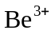 all we need do is replace 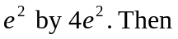
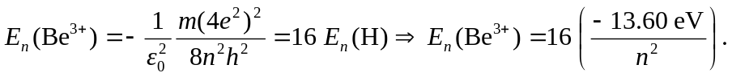
So for the ground state, 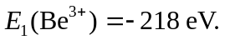
b) The ionization energy is the energy difference between the 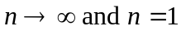 levels. So it is just 218 eV for , which is 16 times that of hydrogen.
c) 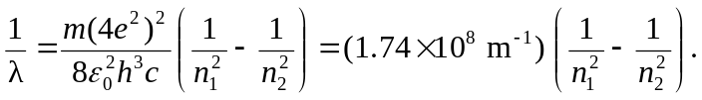
So for 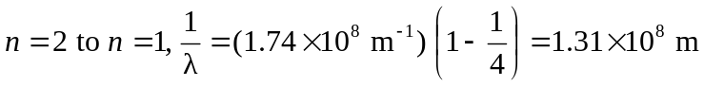
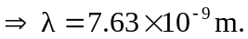 This is 16 times shorter than that from the hydrogen atom.
d) 